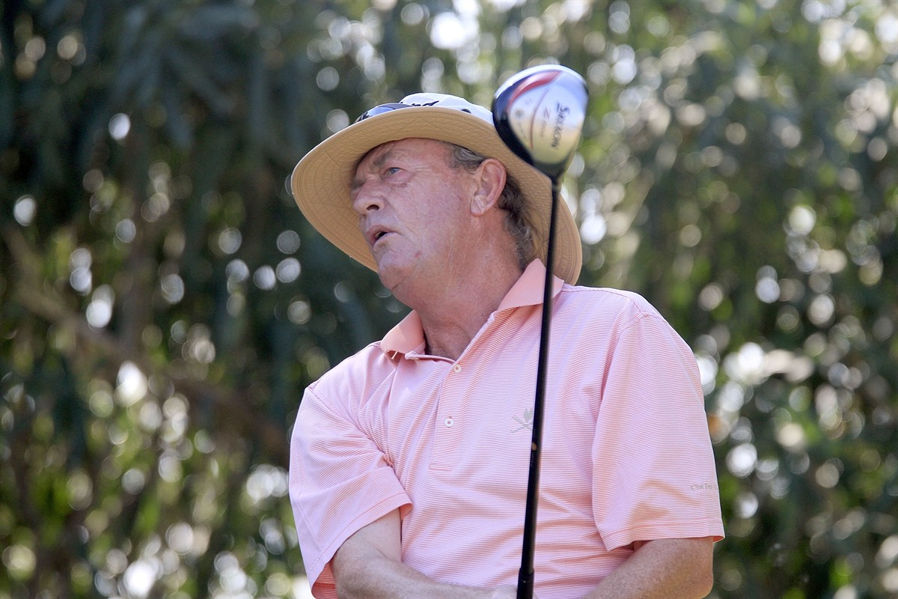

**Carl Mason now 58, has won the European Seniors Tour Order of merit 3 times and been second twice and third one time in the 8 years since he started on the Senior Golf Tour. He holds the record for most tournament wins and heads the all-time money-winners’ list.**

**Having played 19 years on The European Tour without a win though, that breakthrough did not come easy for Mason; but when it did come, at the 1994 Open de España, it certainly changed his perspective. Another European Tour victory followed that year, at the Scottish Open, but it was when he entered the domain of the Senior Tour that the floodgates well and truly opened. Now, 25 titles later, that knack of winning tournaments which proves elusive to so many players clearly comes second nature to Mason.**

**However, it hasn’t been easy for Carl. Like many golfers in their 50’s, he has had his share of injuries and “wear and tear”.**

**“The locker room at each tournament is like a mobile pharmacy, with all the guys needing anti-inflammatories and pain killers to get through the 4 days of tournament golf each week! The tour physios are kept constantly occupied,” says Carl. “2011 has been a watershed year for me, and the thought of not winning a tournament this year has been at the back of my mind. I have suffered in the early part of the season with considerable back pain causing me to back out of a number of tournaments; My orthopaedic specialist, Dr Hugo Kitchen in Stratford-upon-Avon, has been trying to keep me looser and more mobile, but a breakthrough came in the early summer when he introduced me to a supplement which he has designed and researched over the last few years and has benefitted many of his patients”**

**Carl winning the Benhavis Masters at Marbella October 2011**

**Hydrolysed Collagen to treat Joint Pain**

**The intake of hydrolysed collagen, especially in the high bioavailable form of B rejuvenated®, has been found to help repair ligaments, cartilage and bone; and reduce joint pain, swelling and stiffness. It is a main building block of all connective tissue, cartilage and bone.**

[](http://alicsur.com/)

**To learn more about B-Rejuvenated 100% Collagen Capsules take a look at** [**www.alicsur.com**](http://www.alicsur.com) **where you can order your supplies today.**

**“I have been taking B-Rejuvenated 100% Collagen Capsules for over 3 months now and the difference has been quite remarkable. It was slow at first, but taking them religiously every day, I can now say that I have full mobility and am virtually symptom free; The impact has been significant, as I can now swing freely without the fear of having to protect my swing; I just see the shot, get up there and hit it, without any nagging background pain to remind me of what it felt like earlier in the season. For all of you club golfers and pros alike, who suffer little niggles or more serious discomfort during or after your game, I can thoroughly endorse B-Rejuvenated 100% Collagen Capsules as an adjunct to keeping supple and helping to repair your joints and muscle sprains you might get not just through playing but as a result of wear and tear over the years! Importantly the Collagen is pure and contains NO performance enhancing drugs that we might get tested for under tournament rules!”**